**Log in to the Admin Console**

1. Go to the [Keycloak Admin Console](http://localhost:8080/admin).
2. Log in with the username and password you created earlier.

**Create a realm**

A realm in Keycloak is equivalent to a tenant. Each realm allows an administrator to create isolated groups of applications and users. Initially, Keycloak includes a single realm, called master. Use this realm only for managing Keycloak and not for managing any applications.

Use these steps to create the first realm.

1. Open the [Keycloak Admin Console](http://localhost:8080/admin).
2. Click the word **master** in the top-left corner, then click **Create Realm**.
3. Enter myrealm in the **Realm name** field.
4. Click **Create**.

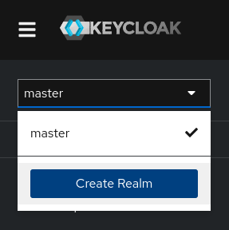

**Create a user**

Initially, the realm has no users. Use these steps to create a user:

1. Open the [Keycloak Admin Console](http://localhost:8080/admin).
2. Click the word **master** in the top-left corner, then click **myrealm**.
3. Click **Users** in the left-hand menu.
4. Click **Add user**.
5. Fill in the form with the following values:
   * **Username**: myuser
   * **First name**: any first name
   * **Last name**: any last name
6. Click **Create**.

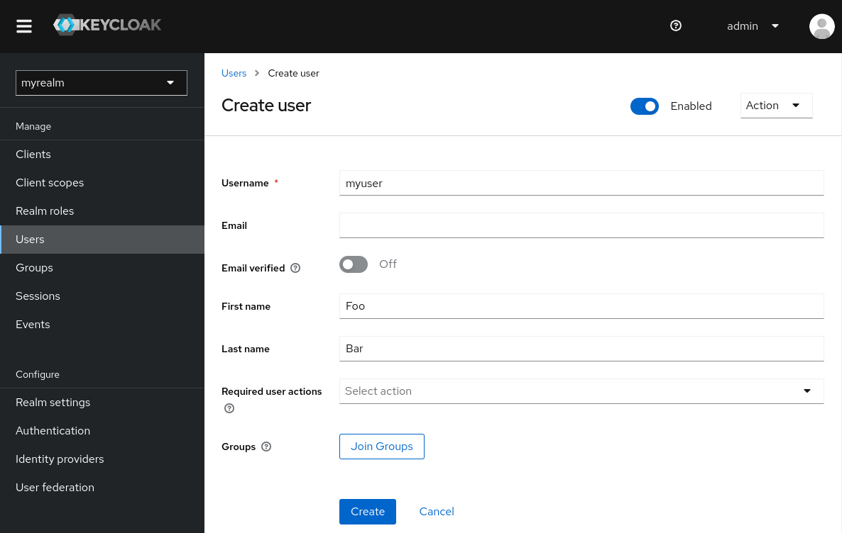

This user needs a password to log in. To set the initial password:

1. Click **Credentials** at the top of the page.
2. Fill in the **Set password** form with a password.
3. Toggle **Temporary** to **Off** so that the user does not need to update this password at the first login.

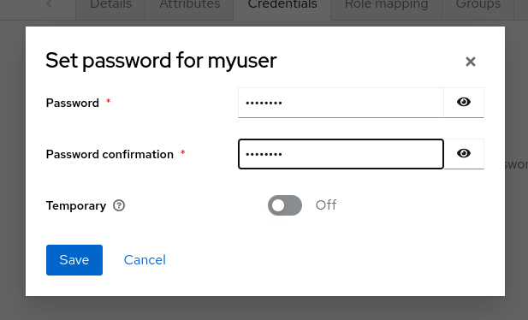

**Log in to the Account Console**

You can now log in to the Account Console to verify this user is configured correctly.

1. Open the [Keycloak Account Console](http://localhost:8080/realms/myrealm/account).
2. Log in with myuser and the password you created earlier.

As a user in the Account Console, you can manage your account including modifying your profile, adding two-factor authentication, and including identity provider accounts.

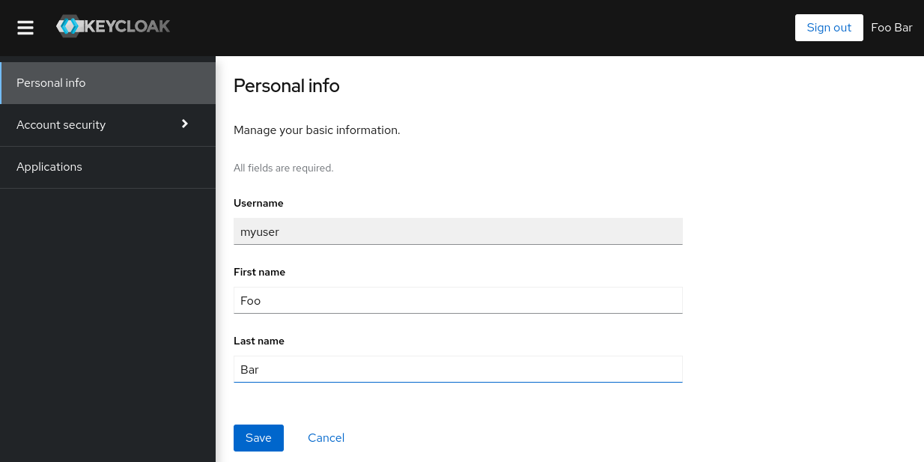

**Secure the first application**

To secure the first application, you start by registering the application with your Keycloak instance:

1. Open the [Keycloak Admin Console](http://localhost:8080/admin).
2. Click the word **master** in the top-left corner, then click **myrealm**.
3. Click **Clients**.
4. Click **Create client**
5. Fill in the form with the following values:
   * **Client type**: OpenID Connect
   * **Client ID**: myclient

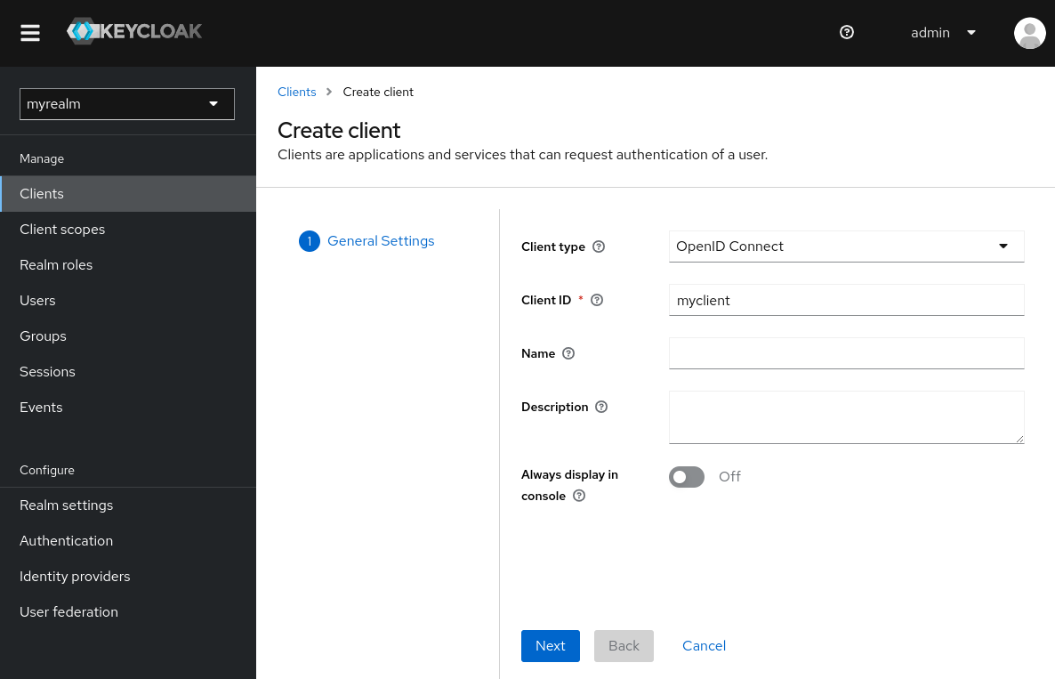

1. Click **Next**
2. Confirm that **Standard flow** is enabled.
3. Click **Next**.
4. Make these changes under **Login settings**.
   * Set **Valid redirect URIs** to https://www.keycloak.org/app/*
   * Set **Web origins** to https://www.keycloak.org
5. Click **Save**.

**Welcome to our Keycloak Administration tutorial! Today, we'll go through the process of setting up Keycloak, creating a realm, adding users, and securing an application. Let's get started!**

**1. Log in to the Admin Console**

1. **Open the Keycloak Admin Console:**
   * First, navigate to the Keycloak Admin Console URL.
2. **Log in:**
   * Use the username and password you created earlier to log in.

**2. Create a Realm**

A realm in Keycloak is like a tenant. Each realm allows an administrator to create isolated groups of applications and users. Initially, Keycloak includes a single realm, called master. We will use this realm only for managing Keycloak itself and not for any applications.

**Steps to create a new realm:**

1. **Open the Keycloak Admin Console.**
2. **Navigate to Create Realm:**
   * Click on the word master in the top-left corner.
   * Click on Create Realm.
3. **Enter Realm Details:**
   * In the Realm name field, type myrealm.
   * Click Create.

**3. Create a User**

Initially, the new realm has no users. We will create a user with the following steps:

1. **Open the Keycloak Admin Console.**
2. **Navigate to the New Realm:**
   * Click on the word master in the top-left corner.
   * Click on myrealm.
3. **Add a User:**
   * Click on Users in the left-hand menu.
   * Click Add user.
4. **Fill in User Details:**
   * Username: myuser
   * First name: (Enter any first name)
   * Last name: (Enter any last name)
   * Click Create.
5. **Set User Password:**
   * Click on Credentials at the top of the page.
   * Fill in the Set password form with a password.
   * Toggle Temporary to Off so that the user does not need to update the password at first login.
   * Click Set Password.

**4. Log in to the Account Console**

To verify that the user is configured correctly, follow these steps:

1. **Open the Keycloak Account Console.**
2. **Log in:**
   * Use the username myuser and the password you set earlier.
3. **Manage Your Account:**
   * In the Account Console, you can manage your profile, add two-factor authentication, and include identity provider accounts.

**5. Secure the First Application**

Now, let’s secure an application by registering it with Keycloak.

1. **Open the Keycloak Admin Console.**
2. **Navigate to the New Realm:**
   * Click on the word master in the top-left corner.
   * Click on myrealm.
3. **Create a Client:**
   * Click on Clients.
   * Click Create client.
4. **Fill in Client Details:**
   * Client type: OpenID Connect
   * Client ID: myclient
   * Click Next.
5. **Configure Client Settings:**
   * Ensure Standard flow is enabled.
   * Click Next.
6. **Update Login Settings:**
   * Set Valid redirect URIs to https://www.keycloak.org/app/*
   * Set Web origins to https://www.keycloak.org
   * Click Save.

**6. Confirm Client Creation**

To confirm that the client was created successfully, use the SPA testing application on the Keycloak website.

1. **Open the SPA Testing Application:**
   * Go to https://www.keycloak.org/app/.
2. **Save and Test:**
   * Click Save to use the default configuration.
   * Click Sign in to authenticate using the Keycloak server you started earlier.

**And that's it! You've successfully set up Keycloak, created a realm, added a user, and secured an application. Well done!**

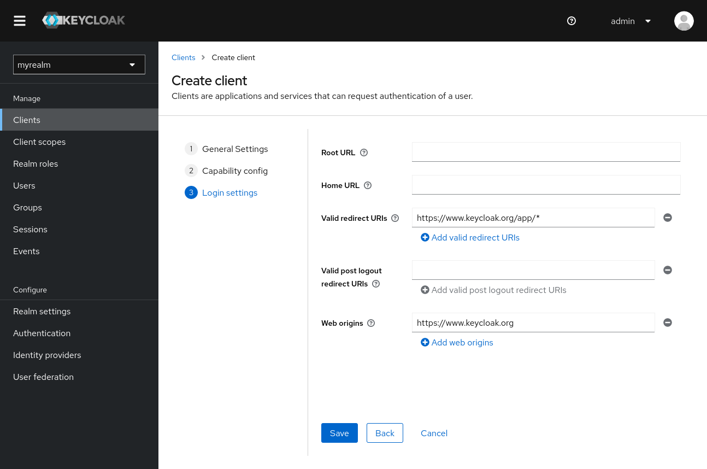

To confirm the client was created successfully, you can use the SPA testing application on the [Keycloak website](https://www.keycloak.org/app/).

1. Open <https://www.keycloak.org/app/>.
2. Click **Save** to use the default configuration.
3. Click **Sign in** to authenticate to this application using the Keycloak server you started earlier.